**MATHEMATICS  
Methods Units 1 & 2**

**Test 1 – Relationships, Functions, Linear and Quadratic Functions**

**Semester 1 2020**

**Section One - Calculator Free**

Time allowed for this section

Working time for this section: 25 minutes

Marks available: 25 marks

## Material required/recommended for this section

##### To be provided by the supervisor

This Question/Answer booklet

Formula sheet

##### To be provided by the candidate

Standard items: pens, pencils, pencil sharpener, eraser, correction fluid, ruler, highlighters

Special items: Nil

## Important note to candidates

No other items may be used in this section of the examination. It is **your** responsibility to ensure that you do not have any unauthorised notes or other items of a non-personal nature in the examination room. If you have any unauthorised material with you, hand it to the supervisor **before** reading any further.

|  |  |  |
| --- | --- | --- |
| **Calculator Free** | **/25** | **%** |
| **Calculator Assumed** | **/33** | **%** |
| **Total** | **/58** | **%** |

**Mathematics Methods, Year 11, 2020**

**Test 3 – Sets, Probability and Counting.**

**Question 1 [4 marks: 1, 1, 2 ]**

a) Calculate 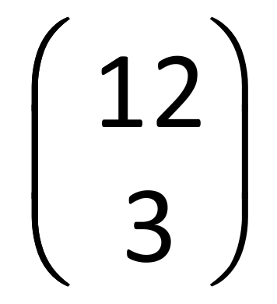

b) Calculate the value of the variable in each of the following:

(i) $\left(\begin{matrix}n \\ 4\end{matrix}\right)=\frac{15!}{11!×4!}$

(ii) $\left({{}_{}^{9}C}_{r}^{}\right)=\frac{9×8×7×6}{4×3×2×1}=$

$\left(\begin{matrix}12 \\ 3\end{matrix}\right)=\frac{12!}{9!×3!}=y$

**Question 2 [10 marks: 1, 5, 4]**

Consider the expansion of (3x – y)4 .

1. (i) How many terms are there in this expansion?

(ii) Expand and simplify the expression, in descending powers of x.

b) State the coefficient of the second term of the expansion of (x2-2y)3 ?

**Question 3 [3 marks: 1, 2]**

1. Describe the following shaded region in terms of A and B using set notation.

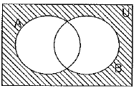

1. Shade the following region $\left(A∩\overline{B}\right)$

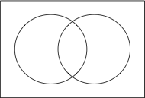

**Question 4 [8 marks: 3, 4, 1]**

A survey of 56 Year 10 students revealed that the number of students owning a bicycle and scooter was four times larger than the number who owned only a bicycle. The number of students owning a scooter and not a bicycle was 10 less than the number who owned both. Three students own neither a bicycle nor a scooter.

**Let x be the number who owned only a bicycle.**

1. Use the above information to complete the Venn diagram below in terms of x.

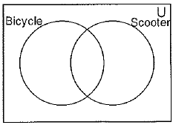

1. By solving for x, complete the Venn diagram below, stating the number of students in each category.



(c) What is the probability that a student who owned a bicycle also owned a scooter?

**MATHEMATICS  
Methods Units 1 & 2**

**Test 1 – Relationships, Functions, Linear and Quadratic Functions**

**Semester 1 2020**

**Section One - Calculator Assumed**

Time allowed for this section

Working time for this section: 33 minutes

Marks available: 33 marks

## Material required/recommended for this section

##### To be provided by the supervisor

This Question/Answer booklet

Formula sheet

##### To be provided by the candidate

Standard items: pens, pencils, pencil sharpener, eraser, correction fluid, ruler, highlighters

Special items: Nil

## Important note to candidates

No other items may be used in this section of the examination. It is **your** responsibility to ensure that you do not have any unauthorised notes or other items of a non-personal nature in the examination room. If you have any unauthorised material with you, hand it to the supervisor **before** reading any further.

|  |  |  |
| --- | --- | --- |
| **Total** | **/33** | **%** |

Name:

**Mathematics Methods, Year 11, 2017**

**Test 3 – Sets, Probability and Counting.**

**Question 5 [8 marks: 2, 2, 2, 2]**

A squad of $12$ cyclists is to be chosen at random from $16$ applicants. $7$ of applicants live in New South Wales, $4$ live in Victoria and the rest live in WA.

(a) Determine the number of different squads that can be chosen. (2 marks)

(b) Determine the number of different squads that can be chosen that

(i) include all the cyclists from Victoria. (2 marks)

(ii) include an equal number of cyclists from each of the states. (2 marks)

(iii) have no more than one cyclist from Victoria. (2 marks)

**Question 6 [10 marks: 5, 1. 2. 2]**

An analysis of new cars sold recently showed that 80% had automatic transmission (event A) and that 68% were classified as having a small to medium sized engine (event S). It was also noted that 56% of cars had both automatic transmission and a small to medium sized engine.

1. Use the above information to complete all the probabilities in this tree diagram

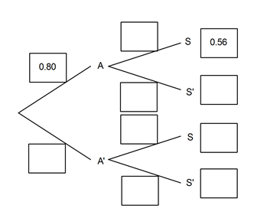

1. Determine the probability that a randomly selected car will
2. have a small to medium sized engine given that it does not have an automatic transmission.
3. have a small to medium sized engine or have automatic transmission.
4. have automatic transmission given that it has a small to medium sized engine.

**Question 7 [7 marks: 1, 2, 1, 1 2]**

The probabilities of two events A and B are such that P(A) = 0.55 and P(B) = 0.3

Determine:

1. The minimum value of P(A∩B).
2. By considering your answer to part (a), what can you say about events A and B when P(A∩B) is a minimum. Draw a Venn diagram to illustrate this.
3. P(A∪B), using your answer from part (a)
4. The maximum value of P(A∩B)
5. By considering your answer to part (d), what can you say about events A and B when P(A∩B) is a maximum. Draw a Venn diagram to illustrate this.

**Question 8 [8 marks 4, 2, 2]**

Events A and B are such that P(A∩B) = 0.3, P($\overline{AB}$) = 0.2 and P(A) = 2P(A∩B)

1. Use the above information to create **a two-way table** in the space below.
2. Determine P(A|B)
3. Are A and B independent events? Justify your answer.